**Maximize profitability in opening restaurant in New York City**

Shubham Horh

December 1, 2019

1. **Introduction to Business Problem:**

ABC Company wants to open restaurants in New York City. We need to provide business solution to maximize profitability by suggesting locations in neighborhood of Borough of New York City for Saturated Market and Untapped Market and popular cuisines in Borough of New York City.

1. **Data Collection and Cleaning:**
2. URL (https://cocl.us/new_york_dataset) was used to get location of each neighborhood in borough of New York City
3. Web Scrapping of Wikipedia Page (<https://en.wikipedia.org/wiki/Cuisine_of_New_York_City>) was used to get popular cuisine in neighborhood in borough of New York City
4. **Methodology:**

The problem was divided in two parts.

1. In Part 1, Restaurants in the neighborhood of borough of New York City was explored. Foursquare API was used to get Restaurant Venue and URL (https://cocl.us/new_york_dataset) was used to get location of each neighborhood. Saturated Market and Untapped Market was checked in the neighborhood by doing clustering and visualizing the neighborhood in Map.
2. In Part 2, Popular cuisine in neighborhood of borough of New York City was explored by Web Scrapping of Wikipedia Page (<https://en.wikipedia.org/wiki/Cuisine_of_New_York_City>) and visualizing popular cuisines by Word Cloud .
3. **Results:**

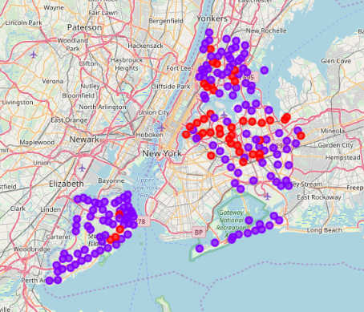

In the map, purple points denote untapped location and red points denote saturated location for opening new restaurant in neighborhood of Boroughs viz. The Bronx, Queens and Staten Island in the New York City.

**Word Cloud of cuisines of Manhattan:**

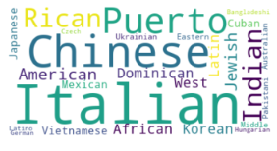

By observing Word Cloud of cuisines of Manhattan, top 3 preferred cuisines of Manhattan:

1. Italian
2. Chinese
3. Puerto Rican

**Word Cloud of cuisines of Brooklyn:**

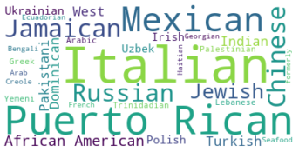

By observing Word Cloud of cuisines of Brooklyn, top 3 preferred cuisines of Brooklyn:

1. Italian
2. Puerto Rican
3. Mexican

**Word Cloud of cuisines of The Bronx:**

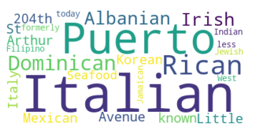

By observing Word Cloud of cuisines of The Bronx, top 3 preferred cuisines of The Bronx:

1. Italian
2. Puerto Rican
3. Dominican

**5. Discussion:**

Let’s consider ABC company wants to open restaurant in the Borough of The Bronx in New York City. We can provide solution by suggesting them to open restaurant in the neighborhood like 'Wakefield', 'Co-op City', 'Eastchester', 'Fieldston', 'Riverdale', 'Woodlawn', 'Norwood', 'Williamsbridge', 'Baychester', 'Pelham Parkway', 'City Island', 'Bedford Park', 'University Heights', 'Morris Heights', 'East Tremont', 'West Farms', 'High Bridge', 'Mott Haven', 'Port Morris', 'Hunts Point', 'Morrisania', 'Soundview', 'Clason Point', 'Throgs Neck', 'Country Club', 'Westchester Square', 'Van Nest', 'Spuyten Duyvil', 'North Riverdale', 'Pelham Bay', 'Schuylerville', 'Edgewater Park', 'Castle Hill', 'Olinville', 'Pelham Gardens', 'Concourse', 'Edenwald', 'Claremont Village', 'Mount Eden', 'Mount Hope', 'Bronxdale', 'Allerton', 'Kingsbridge Heights' instead of neighborhood like 'Kingsbridge', 'Fordham', 'Melrose', 'Longwood', 'Parkchester', 'Morris Park', 'Belmont', 'Unionport', 'Concourse Village' and to have Italian, Puerto Rican, Dominican as top cuisines in those restaurants.

**6. Conclusion:**

With such observation we can provide solution to ABC Company to open restaurant in the given location of untapped market and have preferred cuisine in the restaurant accordingly.